Task 10

1. Chat GPT

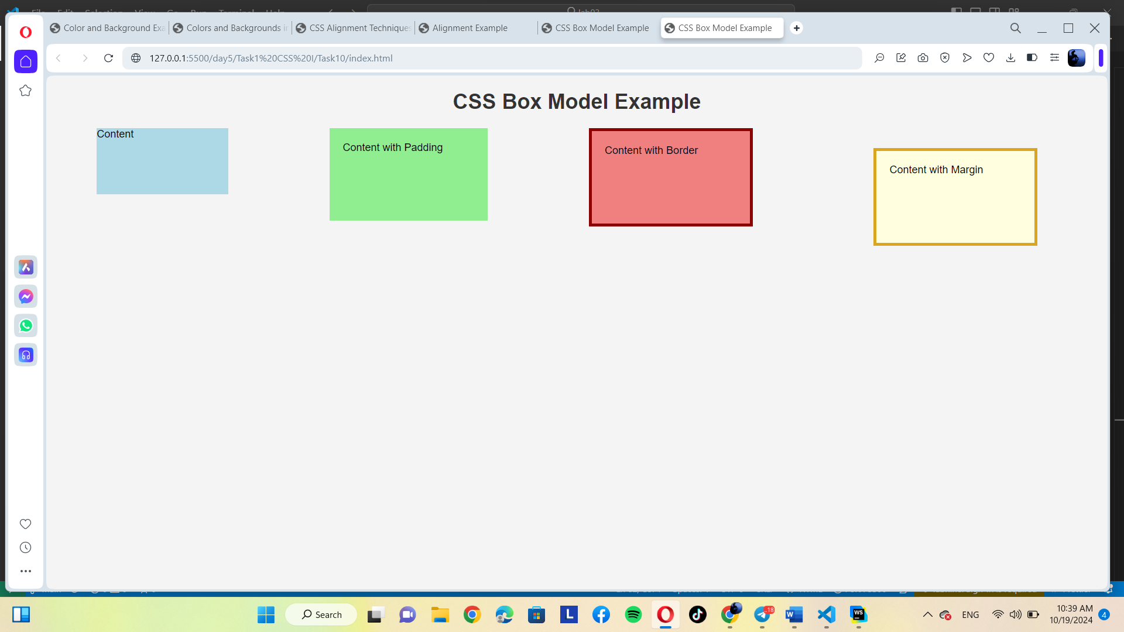

2. Gemini

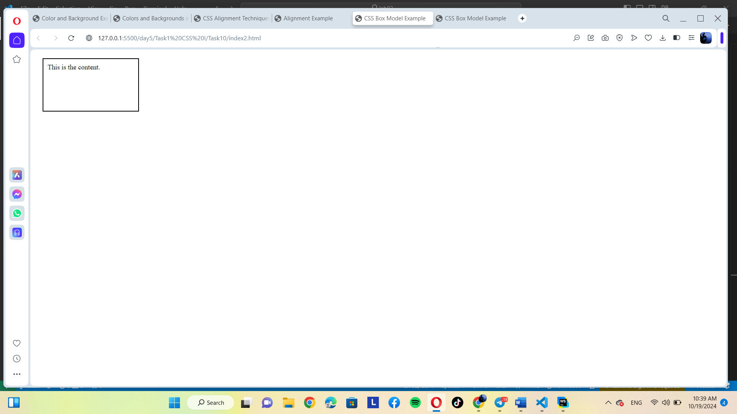

Both follow the prompt.